Statement | Agree | Disagree
I enjoy school.
I feel safe when I am at school.
I learn a lot in lessons.
My work is challenging at times.
Other children behave well in school.
Adults in my school care about me.
Topics are interesting and fun.
I know how well I am doing at school.
My teacher or other adults explain to me how to improve my work.
There are lots of after school clubs.
The Headteacher and teachers in my school do a good job.
There are opportunities to take part in performances in school.
I enjoy having my work put on Twitter.
I like receiving a Marvellous Me message.
Additional comments

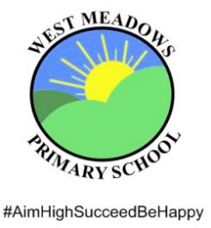
Pupil questionnaire 2019

Please complete the questionnaire below and handback to your class teacher.
Thank you School Council

