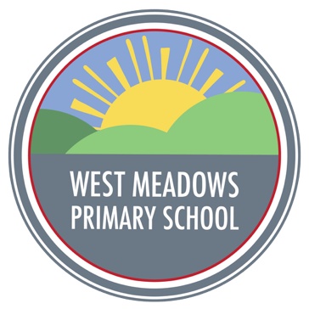
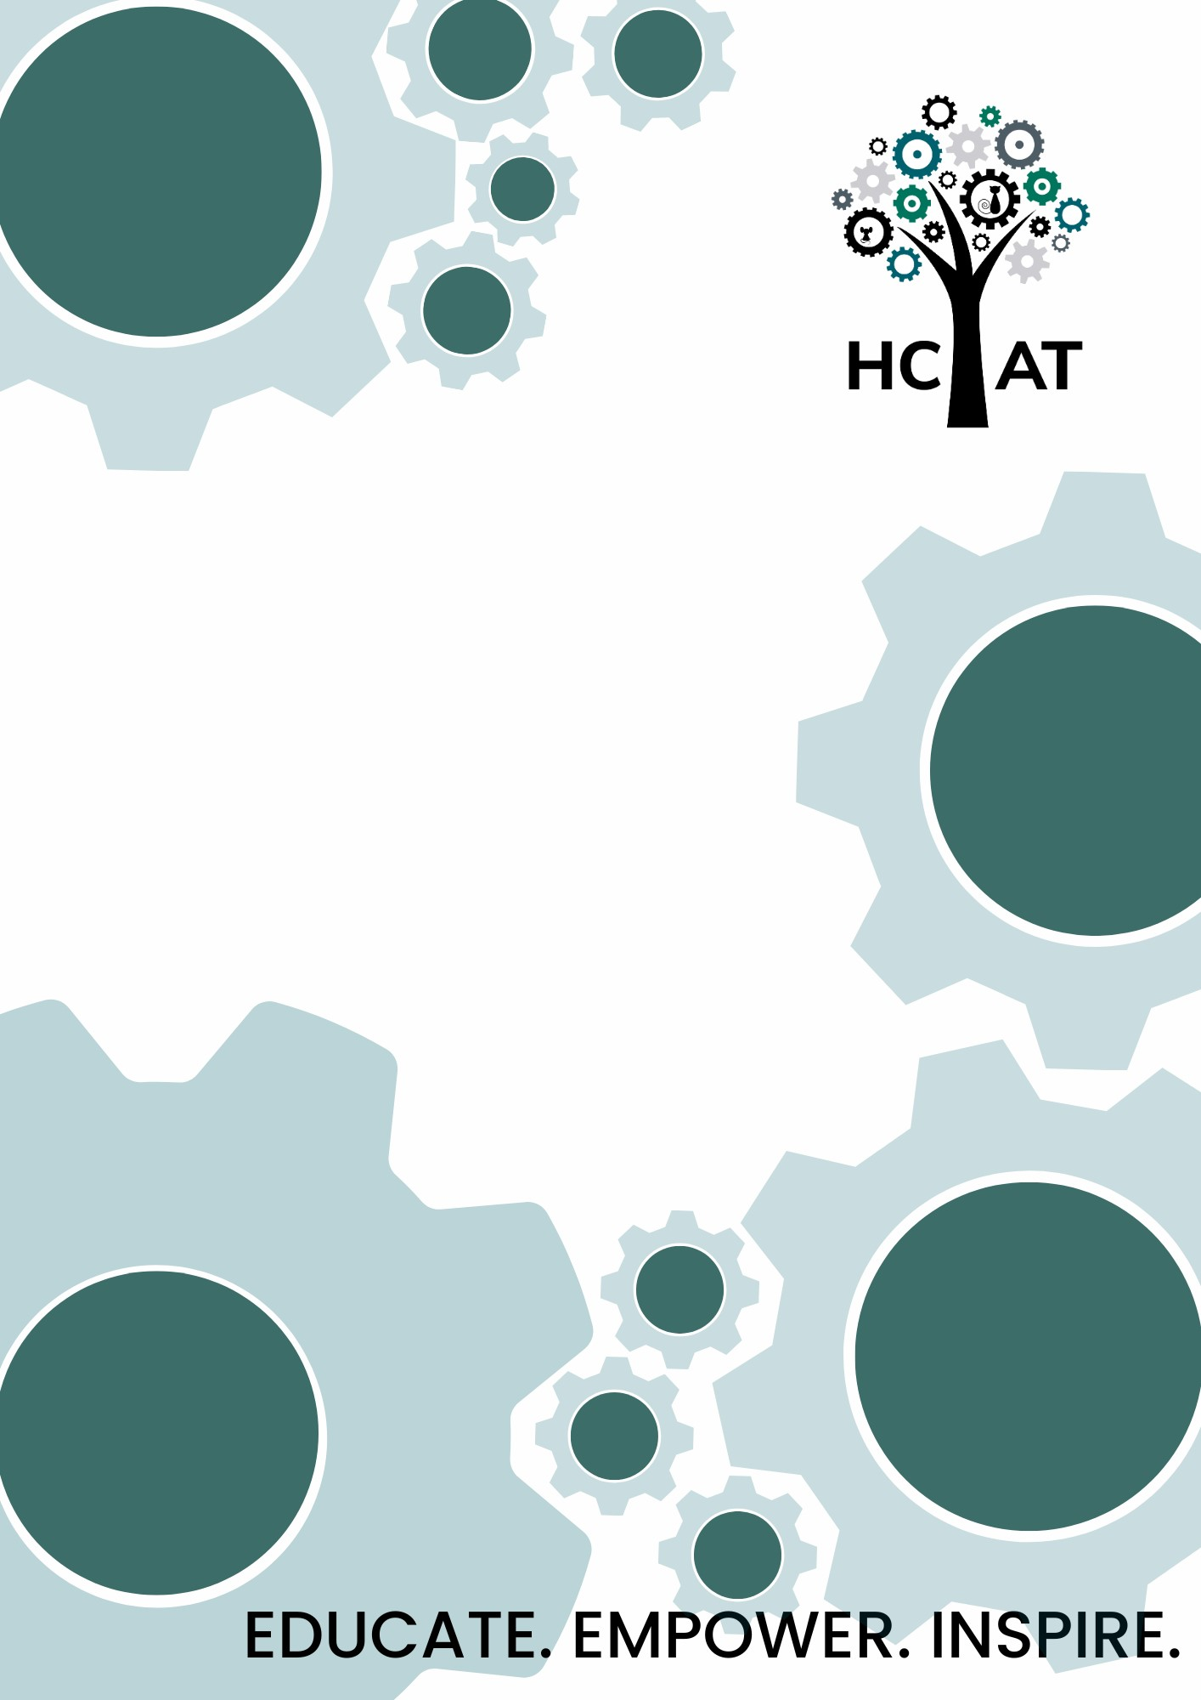
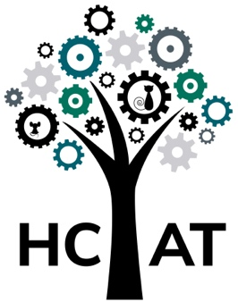

West Meadows Primary
Religious Education Policy

Intent
In line with the National Curriculum and the Six Key Questions of the Barnsley Agreed Syllabus for Religious Education, we have developed our curriculum so that children learn about a variety of religions and social development points throughout their time at school. The West Meadow’s progressive curriculum document supports the progression of substantive content and concepts which have been carefully selected and well-sequenced so a child should know more and revisit knowledge and concepts to ensure depth and rigour over time.
Our well-sequenced RE curriculum prepares pupils with the prior knowledge, including content, concepts and vocabulary, that they need for subsequent key questions in all year groups. At West Meadows, we have identified the necessary background knowledge that pupils need to learn for a topic and ensured that the curriculum is ordered to accommodate this.
RE in school provides a balance of opportunities for children to learn about and learn from religion. We believe that learning from religion provides huge scope for developing children’s spirituality. As a school, we wholeheartedly believe that a high-quality religious education, which promotes a celebration of all cultures and religions, centred around spiritual, moral, social and cultural (SMSC) development is essential in promoting strong shared values among children as well as a knowledge and respect for different people's faiths, feelings and values.
At West Meadows, the RE coverage for each half term has been thoughtfully considered to ensure that all six major world religious are covered in all year groups each term. This ensures that the content of each session is purposeful, meaningful and has a relevant context for our children to engage with.
The intent of our Religious Education curriculum is to provide pupils with a comprehensive and inclusive exploration of religions around the world, fostering understanding, respect and critical thinking. Our approach adapts to a Religion and Worldviews perspective, using local examples to make learning relevant and engaging. Through our curriculum, we address six key questions:
- Why are these words special?
- Why are some places special?
- Why are some times special?
- What can be learned from the lives of significant people of faith?
- How can faith contribute to community cohesion?
- How do I and others feel about life and the universe around us?
These questions guide our pupils to develop a deeper understanding of beliefs, teachings, practises and forms of expression across various faiths. Our RE curriculum aims to give pupils opportunities to learn about and learn from the world's major religions, encouraging them to reflect on their own beliefs and values while appreciating the diversity of others.

Implementation
RE is taught discretely to ensure depth and rigour, whilst being underpinned by the accelerated learning approach to teaching and learning. It is delivered to raise interest, self-esteem, creativity and aspirations of all our children. The curriculum is rich and varied, which provides our pupils with the knowledge and skills required for life in the 21st Century.
Within a sequence of RE lessons, children would be given chance to explore religions through 6 key questions to ensure continuity and progression in each year group. The questions are designed to guide and shape pupils' learning in RE across the years of schooling. Pupils begin by handling the key questions very simply, moving on to learn about and respond to religious objects and ideas, to describe for themselves, to analyse information, and increasingly to develop the ability to draw thoughtful and balanced conclusions.
Ultimately, providing opportunities for children to personally develop by immersing themselves in another culture as well as providing an equality of opportunity so that all pupils can thrive together, is at the heart of the our RE curriculum offer. We aim to develop children's understanding, mutual respect and tolerance allowing pupils’ to gain a greater awareness of their own assumptions and values about the religious content that they study. Therefore, developing responsible, respectful and active citizens who are able to play their part and become actively involved in public life as adults in the 21st Century.
The Accelerated Learning Cycle, based on the work of Alastair Smith, is applied in all lessons. It stems from the idea of a supportive and challenging learning environment. The cycle has active engagement through multi-sensory learning, encourages the demonstrating understanding of learning in a variety of ways and the consolidation of knowing. It is important that children 'know more and remember more' about each religion and can articulate what they know confidently to others
Our curriculum is designed with a core focus on retrieval practice, recognising its pivotal role in helping students know more and remember more. This intent is actualised through a dual approach: integrated retrieval within individual lessons and a structured, subject retrieval practice rota. In-session retrieval activities are carefully crafted to reinforce key concepts and knowledge, promoting immediate recall and application. Complementing this, our weekly retrieval practice rota systematically revisits content across various subjects, ensuring spaced repetition and interleaving of crucial information. This comprehensive strategy aims to strengthen neural connections, facilitate the transfer of knowledge to long-term memory and build increasingly complex mental models. By embedding retrieval practice as a fundamental aspect of our curriculum, we strive to enhance our pupils' ability to retain, recall and apply their learning effectively, thereby fostering deeper understanding and more robust academic progress.
Our curriculum is ambitious for all pupils, including those children with SEND. Curriculum designers and teachers have high expectations of what SEND pupils can achieve and the curriculum is not diluted or unnecessarily reduced for SEND pupils. Every pupil is different and so what works for each pupil varies. Pupil’s individual needs are considered and adaptations are planned to ensure the success of pupils in all subjects.
The way that our curriculum is designed ensures that chunks of learning are sequenced in a coherent way to enable all pupils, including those with SEND, to build on prior knowledge.
Where pupils are identified with having complex needs, it may be appropriate to provide a personalised curriculum which will be based on individual needs and will retain ambition for the pupil.
Where working memory is an issue for pupils, including those with SEND, we look to reduce extraneous load as much as possible as well as identifying key information when teaching. This helps pupils to pay attention to the content which they are expected to learn. Adaptations to support individual pupils will be recorded on personal school support plans.
Pupils’ specific needs determine the types of adaptations which are required. These adaptations are in how the subject is taught rather than the content pupils are expected to learn. Where appropriate, learning will be chunked into smaller steps and pre learning and consolidation time in planned in to support need. Time is also planned to ensure pupils with SEND are pre taught vocabulary to support their understanding. Adaptations may include supporting pupils to pay attention to key aspects as well as reducing excessive or unhelpful demands on working memory.
Impact
Formative assessment is ongoing throughout each lesson. It judges progress and enables the teacher to make flexible adaptations to their planned teaching.
Through this regular ongoing assessment, tasks are matched to the ability of each child through adapted activities and including adult support, thus providing a level of challenge that is stimulating for pupils and questioning skills

their foundation subjects using the Arbor MIS platform to conduct summative assessments at key points in the year. The purpose of these assessments is for our subject leaders and teachers to analyse pupil understanding against our assessment statements, which are progressively devised from our taught curriculum. This allows children to acquire knowledge that builds upon the fundamentals of their prior knowledge in a well-designed curriculum sequence.
As a school, we believe that reflection time is an important step in pupil learning and progress. We ensure that our pupils are given time to reflect upon their learning. Reflection helps us to recognise what and how we have learned and what we need to focus on in the future. Reflection should be about valuing and encouraging pupil involvement – getting them to share ideas, listen to each other and develop the confidence to join in.
Parents Right to Withdraw
Parents have the right to withdraw their children from all or some aspects of religious education and/or collective worship. If you wish for your child to be opted out from sessions, please contact the school office to arrange a meeting with Senior Leaders on kerry.galbraith@hcacademytrust.education

Key Responsibilities for Religious Education:
All staff
All staff will:
- Ensure that they are up to date with the school policy and curriculum requirements regarding RE.
- Attend and engage in professional development training around RE provision, including individual and whole staff training/inset, where appropriate.
- Attend staff meetings to be introduced to any new areas of work and review the effectiveness of the approaches used.
- Report back to RE Lead on any areas they feel are not covered or inadequately provided for in the school’s RE provision.
- Tailor their lessons to suit all pupils in their class, across the whole range of abilities, including those pupils with special educational needs.
- Ask for support in this from SEND coordinator or the RE Lead, should they need it.
Subject Lead:
- Review the policy on a yearly basis.
- Keep staff up to date on any policy changes.
- Ensure that all staff are able to access and deliver the curriculum.
- Identify training needs and arrange or deliver said training.
- Co-ordinate and arrange religious experiences that enhance our children’s cultural capital

