s | 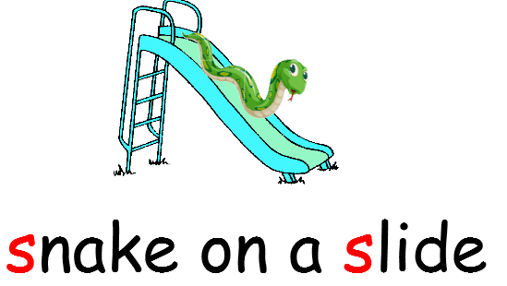 | Bend to the left, then to the right, and then to the left to make a ‘s’
a | 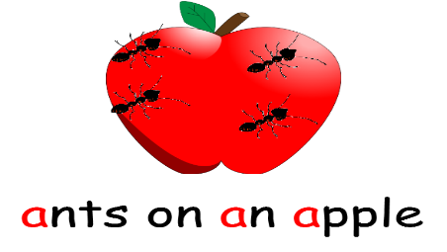 | Let’s go marching in a curve. March to the top and down again.
t | 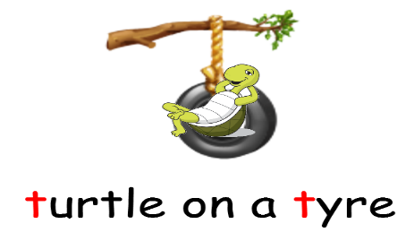 | The turtle travels down the tyre then jumps across
p | 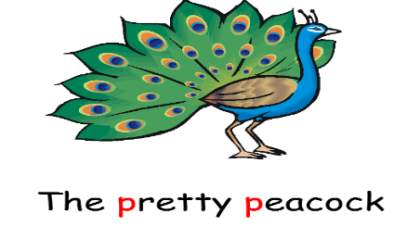 | From head to foot and right around the peacock.
i | 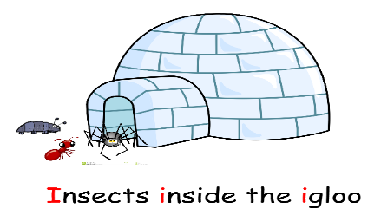 | Down the insects leg. Lift and dot.
n | 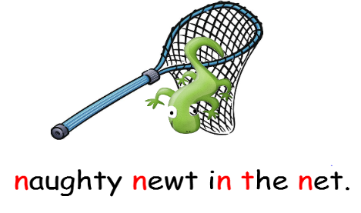 | From the newt’s head to toe and back over the net.
m | 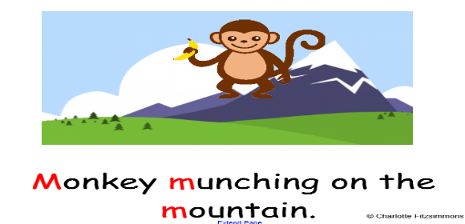 | Monkey walks down and back up and over and over.
d | 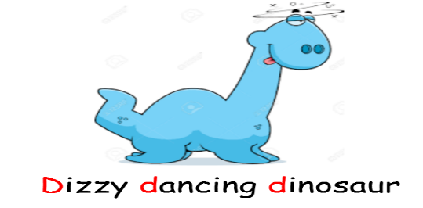 | Left around the dinosaurs back then head back down to toe.
g | 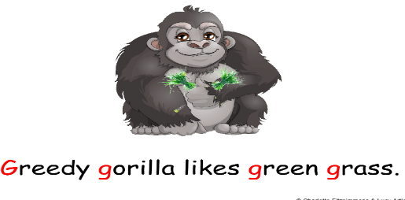 | Left around the gorilla and all the way to the top. Down his leg, add a curl, and stop.
o | 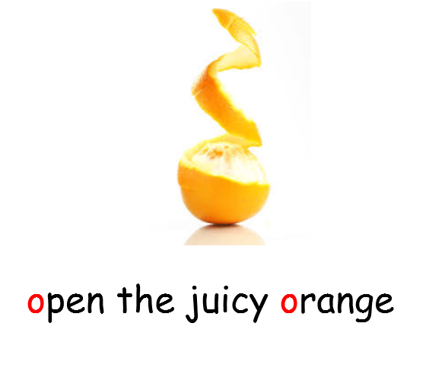 | Left around the orange and all the way to the top.
c | 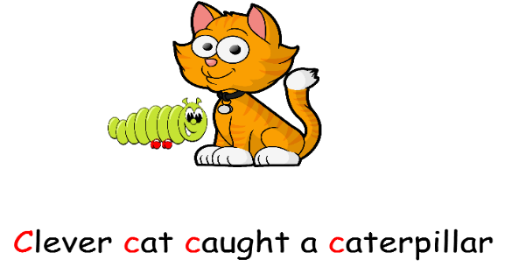 | Left around the clever cat starting from the hat (cat to have a graduation hat on).
k | 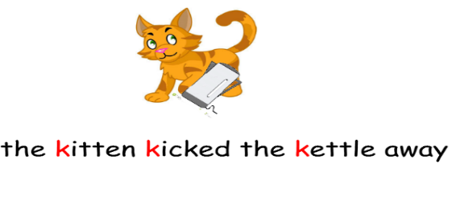 | All the way down the kitten, arm up and kick out.
e | 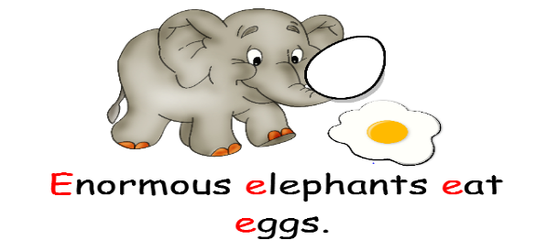 | Stroke under the elephant’s ear and then all around his trunk.
u | 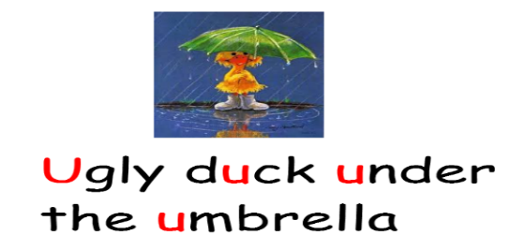 | Go under the umbrella and put it up and down.
r | 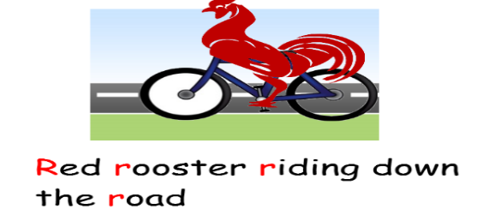 | Make the rooster go down the road, back up and around the bend.
h | 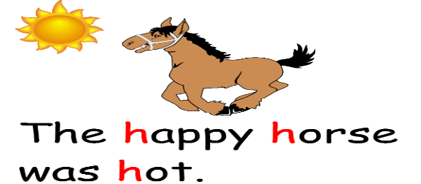 | Start at the top. Go down the horse’s leg and over his back.
b | 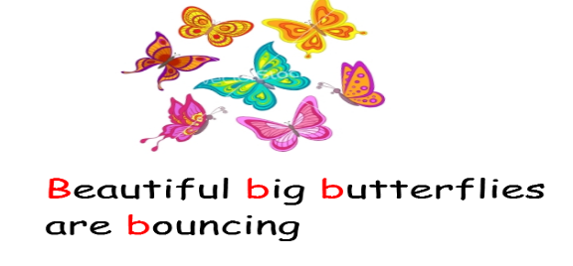 | Start at the top of the tree, go down and back up a little and around the butterfly (tree with a butterfly on it)
f | 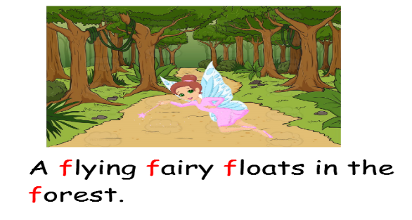 | Curve down the fairy and add her wings.
l | 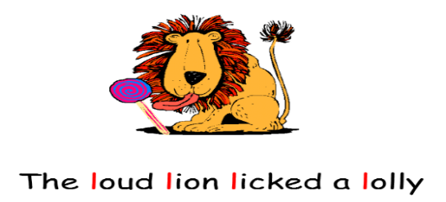 | Start at the top of the lolly stick and go straight down to the bottom.
j | 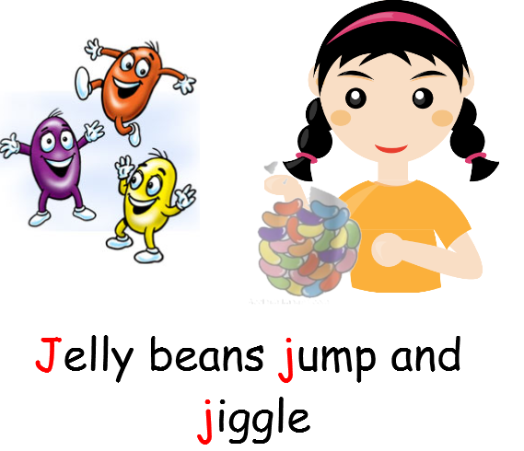 | Start at the top. Go down then girl and jump and dot
v | 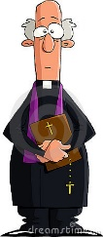  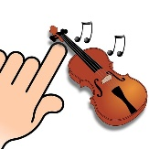  A vicar is playing the violin very loudly | Start at the top and go down and up the violin.
w | 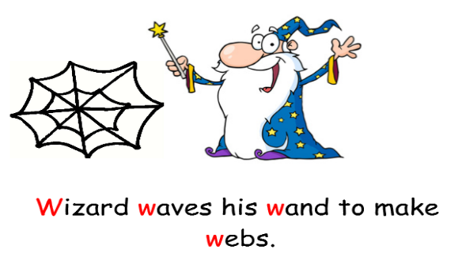 | With your wand go down up down up and cast your spell.
x | 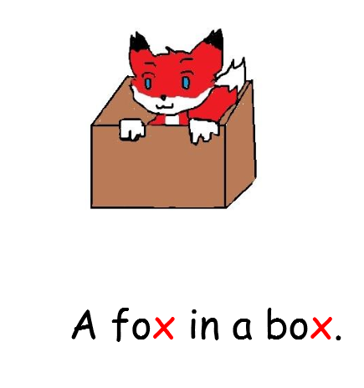 | Left hand to right toe, right hand to left toe.
y | 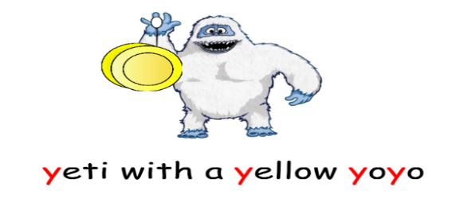 | Draw a smile and go down a yoyo.
z | 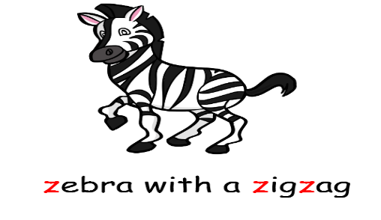 | Zig right, zig left, zig right.
q | 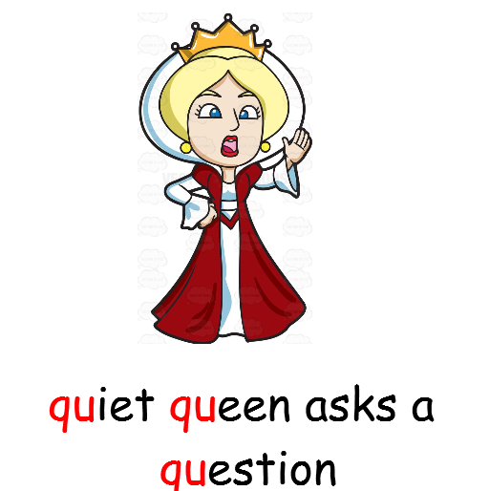 | Left around the queen and down her back and flick.

